ML_2: Gradient Descent Implementation
First we need to :
Generate synthetic data. Say 𝑦=3𝑥+2+𝑛𝑜𝑖𝑠𝑒 to simulate environment for the training,
noise is to make the problem real
Task 1: Implement Cost Function
Mean squared error: 𝑀𝑆𝐸=1𝑛Σ(𝑦𝑖−𝑦̂𝑖)^2 - using formula and numpy
def cost_func(y, y_pred):
n = len(y)
return (1/n) * np.sum((y - y_pred)**2)
Task2 : Implement Gradient Descent:
#weight initialization
w = 0.0
b = 0.0
#LR
lr = 0.01
# #iterative updates
epochs = 100
costs = []

for i in range(epochs):
y_pred = w * x + b #current prediction
# cost
current_cost = cost_func(y, y_pred)
costs.append(current_cost)

# Gradients
n = len(x)
#Gradient of weight
dw = (-2 / n) * np.dot(x, (y - y_pred))
#Gradient of bias
db = (-2 / n) * np.sum(y - y_pred)
#Update Step(Learning Rate )
w = w - (lr * dw)
b = b - (lr * db)
here we took w and b and make them equal to Zero from the very beginning. Why? To train the model and see how much closer we are to the real numbers and see the error (Cost). When we adjust the slope and intercept, Gradients for slope(dw) and bias(db) shows us how much the total error changes. Updated step : w(new) = w(previous) - (lr * dw)-change the slope
b(new) = b(previous) - (lr * db)- change the intercept:
(lr * dw)-how much we adjust the slope , (lr * db) how much we adjust intercept, lr-learnining rate or our steps.
Output is Final Weight (w): 2.979023581648138
Final Bias (b): 1.6911580102766266
Final MSE: 0.6518484069391431
Lets compare with our expression: 𝑦=3𝑥+2+𝑛𝑜𝑖𝑠𝑒 where the real weight is 3 and we got w trained= 2.979023581648138 and the real bias is 2 and the b trained is 1.6911580102766266, so we got the MSE or deviaton : 0.6518484069391431
Plot Training Process Plot: cost vs iterations
plt.figure(figsize=(10, 5))
plt.plot(range(epochs), costs, color='green')
plt.title('COST (MSE) vs. ITERATIONS')
plt.xlabel('NUMBER of ITERATIONS')
plt.ylabel('MSE')
plt.grid(True)

plt.show()
Out put:
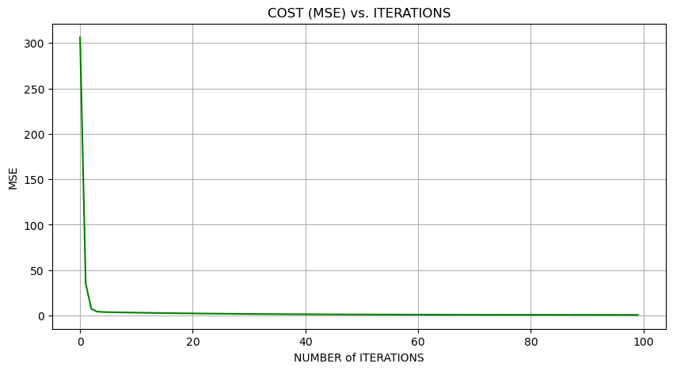on this plot we can see a slight deviation…..

